VETS CONSENT FORM
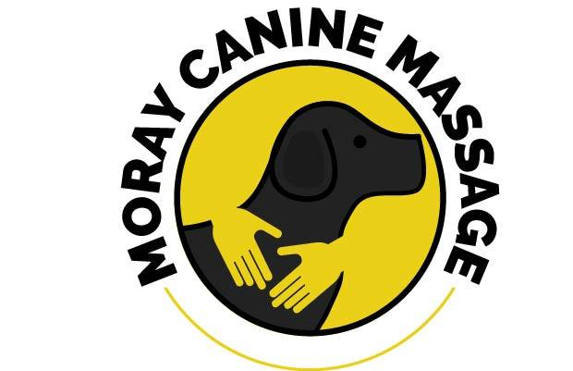
Practice Stamp

Date:
Veterinary Practice Name and Address:

Veterinary Surgeon: ……………………………………………………………M.R.C.V.S
Details of Galen Therapist Requesting Consent
Name: CARLEY JACK
Mob: 07866432072
Email: carley@moraycaninemassage.co.uk
Professional Indemnity and Public Liability Insurance Policy details:
Cliverton Insurance Policy Number JACX03HY01
Details of Dog
Dog's Name:
Handler's Name:
Handler's Address:
E-Mail: Tel No:

Reason for treatment:

Veterinary Diagnosis:

Relevant pre-existing conditions:

I consent to Carley Jack performing Canine Myotherapy Treatment (soft tissue manipulation, and other massage techniques including Passive Movement Exercises), along with Photizo Light Therapy, where appropriate, for soft tissue, specifically muscular conditions on the above named dog.
Please indicate how you would like to receive the subsequent treatment report
Written report Verbal report E-mail Report
Email address.....................................................................................................
I understand that by giving consent, I am not responsible for any Myotherapy or Photizo Light Therapy treatment given and the provision of professional indemnity insurance for this is the responsibility of Carley Jack
Signed: ………………………………………………………
M.R.C.V.S. (Veterinary Surgeon)
Date………………..………………
PLEASE RETURN THE ABOVE SIGNED FORM TO: Carley Jack at carley@moraycaninemassage.co.uk

